FOR IMMEDIATE RELEASE

TACTICAL ROLE-PLAYING GAME, TRIANGLE STRATEGY COMING TO PC ON OCTOBER 13

Digital Pre-Purchase Now Available for Steam

LONDON (Sept. 13, 2022) – Square Enix Ltd., today announced that turn-based tactical role-playing game, TRIANGLE STRATEGYTM is launching on PC (STEAM®) on October 13, 2022. Having previously released globally to positive reception on Nintendo Switch™ system in March 2022, TRIANGLE STRATEGY is an exciting HD-2D tactical RPG from the award-winning development team behind OCTOPATH TRAVELER™ and BRAVELY DEFAULT™, featuring a strategic turn-based battle system, deep branching story and arduous moral choices. Pre-purchase on Steam available now!

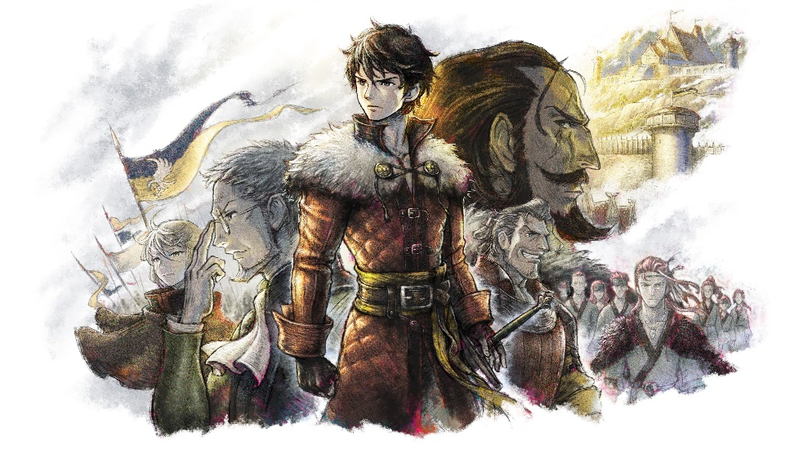
Watch the TRIANGLE STRATEGYTM | Announcement Trailer here: https://youtu.be/eNqo4Q0YXO0
TRIANGLE STRATEGY takes place on the continent of Norzelia, where players will determine the fate of three powerful kingdoms embroiled in conflict, Glenbrook, Aesfrost, and Hyzante. Set 30 years after the “Saltiron War,” players will guide protagonist Serenoa Wolffort and his faithful companions, childhood friend Prince Roland, fiancée Princess Frederica Aesfrost, and the steward of House Wolffort Benedict, as they attempt to navigate their way through this new conflict.

TRIANGLE STRATEGY offers a complex, tactical battle system that utilizes a lush, interactive RPG environment. Players will have the ability to:
- Choose from three different philosophies, pragmatic utility, virtuous morality or liberty, to help shape the story
- Select from 30 characters to create their own unique battle team
- Utilize unique attributes, set movement per range offered by each character, as well as use special attacks and skills that consume a limited but rechargeable pool of Tactical Points per character
- Level up characters by using them in battle to increase their attributes and to unlock new special attacks and skills
- Upgrade individual attributes and characters classes, making them more effective in combat

Players who (pre)purchase the digital Standard or Deluxe Edition of TRIANGLE STRATEGY before October 13, 2022 on PC will receive a pre-purchase discount of 10% off. TRIANGLE STRATEGY Digital Deluxe Edition will also be available as part of a bundle with VARIOUS DAYLIFE on PC via the STEAM Store. Players who purchase this bundle on PC (STEAM®) will receive a 10% discount on the TRIANGLE STRATEGY Digital Deluxe Edition included in the bundle, and afterward a 29% discount on the entire bundle, which includes a VARIOUS DAYLIFE digital artbook, when it launches on PC on October 13, 2022. *

*At participating retailers only.

TRIANGLE STRATEGY is Rated PEGI 12. For more information, visit: https://www.square-enix-games.com/de_DE/games/triangle-strategy

Related Links:
Official Website:
Twitter: https://www.twitter.com/SquareEnix
Facebook: https://www.facebook.com/SquareEnix
YouTube: https://www.youtube.com/SquareEnixNA
#TriangleStrategy

About Square Enix, Inc.
Square Enix Ltd. develops, publishes, distributes and licenses SQUARE ENIX® and TAITO® branded entertainment content in Europe and other PAL territories as part of the Square Enix group of companies. The Square Enix group of companies boasts a valuable portfolio of intellectual property including: FINAL FANTASY®, which has sold over 173 million units worldwide; DRAGON QUEST®, which has sold over 85 million units worldwide; and the legendary SPACE INVADERS®. Square Enix Ltd. is a London-based, wholly owned subsidiary of Square Enix Holdings Co., Ltd.

More information on Square Enix Ltd. can be found at https://square-enix-games.com

# # #

©2022 SQUARE ENIX CO., LTD. All Rights Reserved.

