FOR IMMEDIATE RELEASE

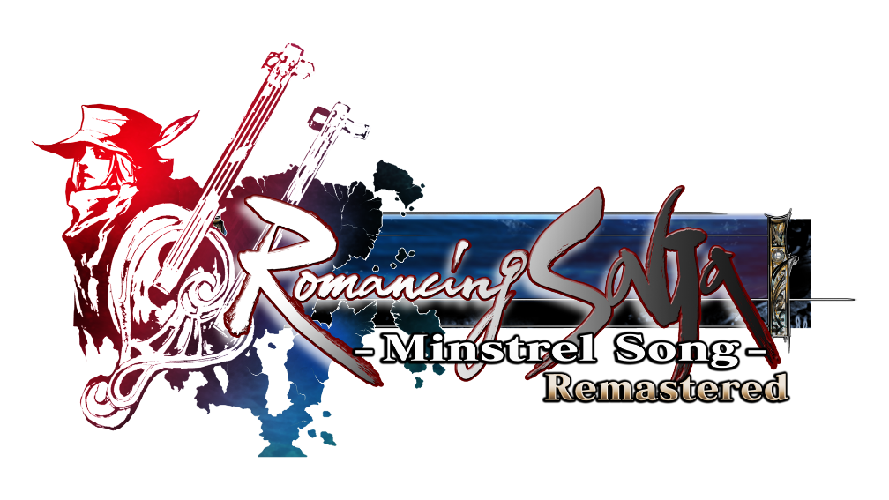

SQUARE ENIX REVEALS ROMANCING SAGA -MINSTREL SONG- REMASTERED AS NEXT RELEASE FOR THE BELOVED SAGA FRANCHISE.

Launching On PlayStation®5 (PS5™) Console, PlayStation®4 (PS4™) Console, Nintendo Switch™ system, PC (STEAM®), iOS and Android This Winter.

LONDON (MAY 31, 2022) – SQUARE ENIX® today announced that the fourth entry in the beloved SaGa series, “Romancing SaGa” which originally released in Japan in 1992, and again as a remake in 2005 across North America and Japan, is coming to Europe for the first time this winter as Romancing SaGa -Minstrel Song- Remastered on PlayStation®5 (PS5™) console, PlayStation®4 (PS4™) console, Nintendo Switch™ system, PC (STEAM®), iOS and Android devices.
Watch the Romancing Saga -Minstrel Song- Remastered | Announce Trailer here:
https://youtu.be/1-sMRwc5boM
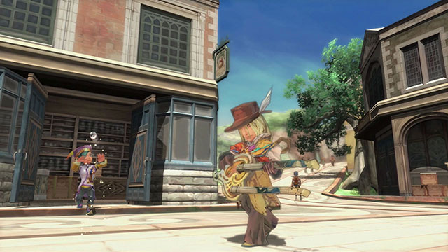

Romancing SaGa -Minstrel Song- Remastered will feature a host of exciting new improvements and additions, including remastered graphics, new quality of life features to improve playability, and new gameplay features. Players will follow the exploits of one of eight protagonists, each with their own storyline and goal, and create their own unique adventure where their actions will affect the world around them courtesy of the “Free-form Scenario” system.
Fans of the SaGa series can also expect the “Glimmer” and “Combo” systems from previous games, iconic beautifully illustrated designs, and a whimsical soundtrack by Composer Kenji Ito which can be heard in today’s teaser trailer with the charming theme song “Menuett” from the game’s soundtrack.
Romancing SaGa -Minstrel Song- Remastered is the latest announcement from the ongoing SaGa Project from SQUARE ENIX that has so far included Western releases of Romancing SaGa 3, SaGa SCARLET GRACE: AMBITIONS, hit mobile game Romancing SaGa™ Re;univerSe™, and SaGa Frontier Remastered.

Related Links:
Official Website
Twitter: https://www.twitter.com/SaGaGame
Facebook: https://www.facebook.com/SquareEnix
YouTube: https://www.youtube.com/c/squareenixna

About the SaGa Series
SaGa is a series of revolutionary role-playing games, created by legendary game developer Akitoshi Kawazu (FINAL FANTASY, FINAL FANTASY II, SaGa Frontier). Since THE FINAL FANTASY LEGEND was released in 1990 for the Game Boy, the series has expanded with several additional entries across numerous platforms. Other SaGa series regulars include illustrator Tomomi Kobayashi, who has given the series its own unique style, and composer Kenji Ito (Mana series). Although the SaGa series shares its roots with FINAL FANTASY, the SaGa series has always incorporated revolutionary and challenging gameplay mechanics, such as player choice, branching storylines and implementing characters with wildly different playstyles, setting it apart from other JRPG series. Romancing SaGa 3 launched for the first time outside of Japan on November 11, 2019, exactly 24 years since the game’s initial Japanese release. SaGa SCARLET GRACE: AMBITIONS, an enhanced version of SaGa SCARLET GRACE, also launched for the first time outside of Japan on December 3, 2019.

About Square Enix, Ltd.
Square Enix Ltd. develops, publishes, distributes and licenses SQUARE ENIX®, EIDOS® and TAITO® branded entertainment content in Europe and other PAL territories as part of the Square Enix group of companies. Square Enix Ltd. also has a global network of leading development studios such as Crystal Dynamics® and Eidos Montréal®. The Square Enix group of companies boasts a valuable portfolio of intellectual property including: FINAL FANTASY, which has sold over 168 million units worldwide; DRAGON QUEST®, which has sold over 84 million units worldwide; TOMB RAIDER®, which has sold over 88 million units worldwide; and the legendary SPACE INVADERS®. Square Enix Ltd. is a London-based, wholly owned subsidiary of Square Enix Holdings Co., Ltd.

More information on Square Enix, Inc. can be found at https://square-enix-games.com

# # #

© SQUARE ENIX CO., LTD. All Rights Reserved.

ROMANCING SAGA -MINSTREL SONG- REMASTERED, CRYSTAL DYNAMICS, DRAGON QUEST, EIDOS, EIDOS MONTREAL, FINAL FANTASY, SPACE INVADERS, SQUARE ENIX, the SQUARE ENIX logo, TAITO and TOMB RAIDER are registered trademarks or trademarks of the Square Enix group of companies. All other trademarks are properties of their respective owners. "PlayStation,” “PS5,” and “PS4” are registered trademarks or trademarks of Sony Interactive Entertainment Inc. Nintendo Switch is a trademark of Nintendo Co., Ltd. Steam and the Steam logo are trademarks and/or registered trademarks of Valve Corporation in the US and/or other countries. All other trademarks are the property of their respective owners.

