FOR IMMEDIATE RELEASE

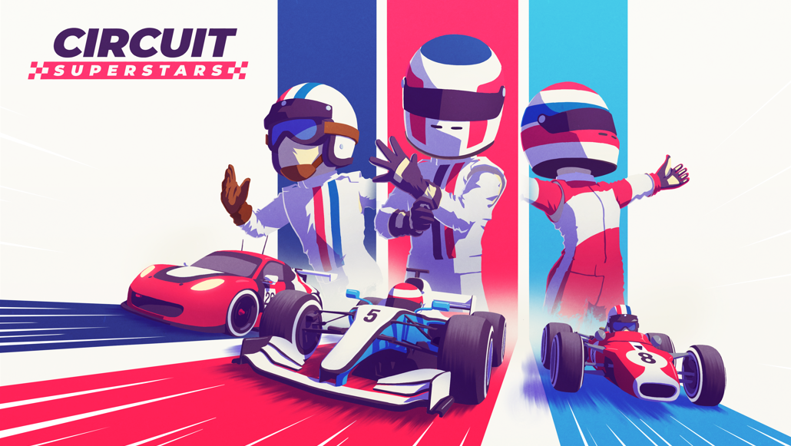

START YOUR ENGINES!
CIRCUIT SUPERSTARS FROM SQUARE ENIX COLLECTIVE IS AVAILABLE NOW

Race your Heroes on the Iconic Top Gear Test Track and Compete for Championship Glory

LONDON ( 12th October, 2021) – SQUARE ENIX® Ltd., and Original Fire Games today released the highly-anticipated top-down racing game CIRCUIT SUPERSTARS, a competitive game with a charming edge; built by racing fans, for racing fans. The game celebrates generations of multi-disciplinary motorsport, focusing on tactile driving that feels great – but also with a high skill ceiling, that will have players spending hours honing their perfect lap. The game is available to purchase on PC via Steam®, Xbox One, and is coming soon to the PlayStation®4 console and Nintendo Switch™ system.

Watch the CIRCUIT SUPERSTARS launch trailer here:
https://youtu.be/6i_fbkRfVf0

Ahead of the game’s launch, CIRCUIT SUPERSTARS was thoroughly put to the test by luminaries from the motorsport and esports world, including IndyCar and former FORMULA 1 driver Romain Grosjean and FORMULA 1 star Lando Norris, alongside teammates from his esport team, Quadrant. As part of a BBC Studios and Top Gear collaboration, they were joined by a top-tier line up of motorsport, esports and YouTube stars who took on the CIRCUIT SUPERSTARS version of Top Gear’s iconic Test Track, in a unique take on the “Star in a Reasonably Fast Car” feature.

The game has launched with a special, free Top Gear DLC that offers players the opportunity to race their heroes on the iconic Top Gear Test Track. The track includes the Top Gear ‘Time Attack’ feature, giving players the unique opportunity to take to the track in a special Stig costume and perfect their racing lines against: Lando Norris, Romain Grosjean, Jamie Chadwick, Sam Bird, Steve “SuperGT” Brown, Charlie Martin, Jimmy Broadbent, Catie Munnings, Aarava and Conor Daly.

Racers will have access to the garage of their dreams, packed with 12 vehicles ready to compete on any of the 19 different tracks available, set in 13 vibrant locations. Players can enjoy a range of customisable liveries for both driver and cars, in addition to helmets and victory celebrations which can be unlocked by levelling up. There’s a racing style for everyone, with multiple motorsport disciplines represented in the game including Rallycross, Open wheel single-seaters, Trucks, GT racing and many more – and plenty more free content to come in the future!

Starting out is simple… but learning the nuances of each car’s unique handling and finding the best racing line around the corners of each track will be challenging. With the option of fuel usage, tire degradation and racing damage, even a good pit stop strategy could make the difference between hero and zero. Feel the rubber bite into the road as you pass the start/finish line and dive, with brakes squealing, into the first corner!

Whether you like to race solo or to challenge your friends, CIRCUIT SUPERSTARS features multiple racing options, including:

- Online Multiplayer – Dive into specially-curated online multiplayer races with up to 12 players from around the globe.
- Split Screen Local Multiplayer – Challenge up to three of your mates and skilful AI drivers
- Grand Prix – Master all disciplines by conquering each of the single player tournaments designed for all 12 categories.
- Free Play Mode – Create your own race events or tournaments

Phil Elliott, Head of Square Enix Collective says: “CIRCUIT SUPERSTARS is a wonderful representation of how developers can combine a deep love of motorsport and of gaming to create something special for both communities. CIRCUIT SUPERSTARS is unique in how it offers charming, relaxed gaming to some players, as well as a challenging, rewarding racing simulation to others, all in the same game.”

Alberto Mastretta, Founder & Creative Director at Original Fire Games says: "Launching CIRCUIT SUPERSTARS is a huge accomplishment for us as a new studio, and we are so excited to release it today. This project has meant the world to us - motorsport has been a significant source of joy throughout our lives, and we have formed bonds with friends and family in physical and virtual race tracks. We have put everything we have into paying homage to the sport we love, to bring those same meaningful experiences to players.”

Carolina Mastretta, Founder & Studio Lead at Original Fire Games further added “Seeing incredible drivers like Lando Norris, Romain Grosjean, Jamie Chadwick and many others resonate with our game is a huge honour, it fuels our energy to keep building on what we’ve created so far. We're excited to be on the track with all of you, sharing those special moments, and celebrating the world of motorsport together!”

CIRCUIT SUPERSTARS is available NOW on PC (via Steam®) and Xbox One. It will also be coming soon to PlayStation®4 console and Nintendo Switch™ system.

For further information please visit: http://www.circuit-superstars.com/

Related Links:
Steam: https://store.steampowered.com/app/1097130/Circuit_Superstars/
Xbox: https://www.microsoft.com/store/productid/9ph3rr8mvfjl
Twitter: https://twitter.com/circuitsup
Facebook: https://www.facebook.com/CircuitSUP/
YouTube: https://www.youtube.com/user/SquareEnixCollective
Instagram: https://www.instagram.com/circuitsuperstars
#TopGear #CSupInvitational

About Original Fire Games
Original Fire Games is a small team originally started by three siblings from Mexico: Carolina, Carlos and Alberto Mastretta. Together they have a combined total of 14 years in game development, as well as more than 15 accumulated years of real motor racing experience. They are bringing every bit of that expertise and passion to Circuit Superstars to make a competitive game with a charming edge. Circuit Superstars is a love letter to the world of motorsport – made for the fans, by the fans.

About Square Enix Collective
Square Enix Collective® is a London-based division of Square Enix Ltd. The Collective programme was launched in 2014 to assist indie game developers build community awareness for hundreds of games pitches and has helped teams to raise in excess of $1.2 million via Kickstarter campaigns. Collective has now published and distributed a range of indie titles since April 2016 and is on the look-out for great new projects and talented teams to work with globally – whether it’s publishing support for a development that’s already funded, or investment to help the creation of a game.

About Square Enix Ltd.
Square Enix Ltd. develops, publishes, distributes and licenses SQUARE ENIX®, EIDOS® and TAITO® branded entertainment content in Europe and other PAL territories as part of the Square Enix group of companies. Square Enix Ltd. also has a global network of leading development studios such as Crystal Dynamics® and Eidos Montréal®. The Square Enix group of companies boasts a valuable portfolio of intellectual property including: FINAL FANTASY, which has sold over 164 million units worldwide; DRAGON QUEST®, which has sold over 83 million units worldwide; TOMB RAIDER®, which has sold over 85 million units worldwide; and the legendary SPACE INVADERS®. Square Enix Ltd. is a London-based, wholly owned subsidiary of Square Enix Holdings Co., Ltd.

More information on Square Enix Ltd. can be found at https://square-enix-games.com.

About BBC Studios
BBC Studios, a global content company with bold British creativity at its heart, is a commercial subsidiary of the BBC Group, supporting the licence fee and enhancing programmes for UK audiences. Able to take an idea seamlessly from thought to screen and beyond, its activities span content financing, development, production, sales, branded services, and ancillaries across both its own productions, and programmes and formats made by high-quality UK independents. Award-winning British programmes made by the business are internationally recognised across a broad range of genres and specialisms, with brands like Strictly Come Dancing/Dancing with the Stars, Top Gear, Doctor Who and Bluey. BBC Studios has offices in over 20 markets globally, including ten production bases in the UK and production bases or partnerships in a further nine countries around the world. The company, which ordinarily makes around 2000 hours of content a year for both the BBC and third parties including Apple, Netflix and Migu, is a champion for British creativity around the world. It is also a committed partner for the UK’s independent sector through a mix of equity partnerships, content investment and international distribution for programme titles.
BBC Studios | Website | Press Office | Twitter | LinkedIn | Instagram |

##
CRYSTAL DYNAMICS, DRAGON QUEST, EIDOS, EIDOS MONTREAL, FINAL FANTASY, SPACE INVADERS, SQUARE ENIX, the SQUARE ENIX logo, TAITO and TOMB RAIDER are registered trademarks or trademarks of the Square Enix group of companies. All other trademarks are properties of their respective owners.
Circuit Superstars © Original Fire Games. All rights reserved. Developed by Original Fire Games. Published by Square Enix Limited. CIRCUIT SUPERSTARS and the ORIGINAL FIRE GAMES logo are trademarks of Original Fire Games.
BBC, TOP GEAR, TG and THE STIG are trade marks of the British Broadcasting Corporation and are used under licence. BBC logo © BBC 1996. TOP GEAR logo © 2005. Licensed by BBC Studios.

