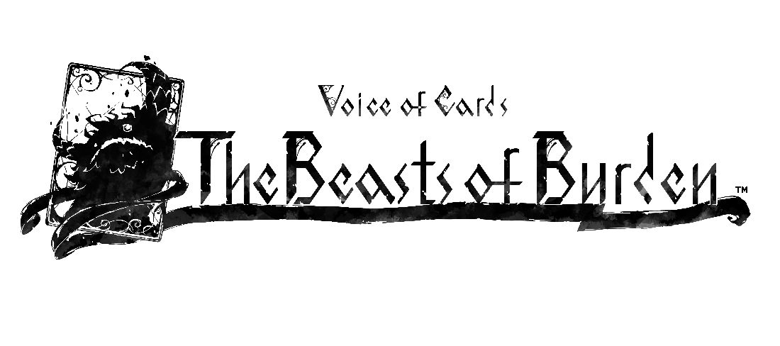
HARNESS THE POWER OF MONSTERS IN VOICE OF CARDS: THE BEASTS OF BURDEN - NOW AVAILABLE
The Third Entry in the Voice of Cards Franchise Makes its Launch Debut for Nintendo Switch, PlayStation®4 and PC via Steam
LONDON (Sept. 13, 2022) – Square Enix Ltd., today announced that the latest standalone addition to the unique Voice of Cards card-based RPG franchise, Voice of Cards: The Beasts of Burden™, is now available digitally for the Nintendo Switch™ system, PlayStation®4 (PS4™) console and PC via Steam®. Following the release of Voice of Cards: The Isle Dragon Roars™ and Voice of Cards: The Forsaken Maiden™, fans can now enjoy a third turn-based adventure in the Voice of Cards franchise told entirely through the medium of cards.

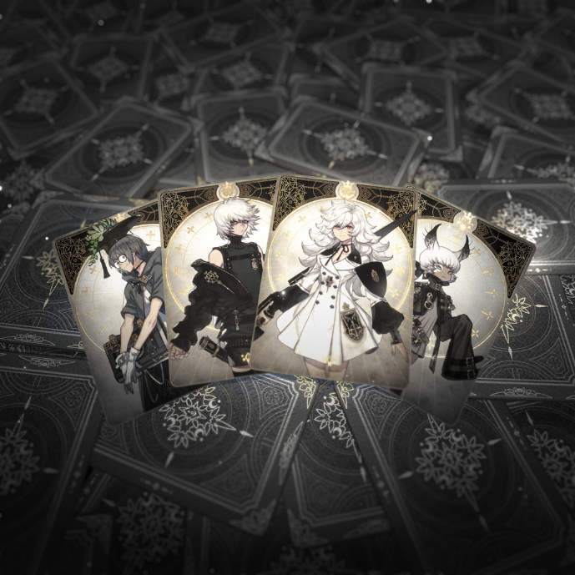
To view the announcement trailer, visit: https://youtu.be/Sta3GwzCVkI
Voice of Cards: The Beasts of Burden brings players to an illustrated world presented through the medium of cards as the third release in the Voice of Cards franchise, now giving players the ability to trap the monsters they defeat in cards to use them as skills in battle. Follow a new tale set in a world where a millennia of hatred rages between monsters and humans, and a girl who loses her home swears revenge on monsters. She joins hands with a mysterious boy as they set out into the unknown and unravel the fate of this broken world.
Players can now enjoy this truly unique gaming experience, brought to life by the creative minds behind the previous Voice of Cards games, beloved NieR™ series and Drakengard® series, including: Creative Director, YOKO TARO (Drakengard series, NieR series), Music Director, Keiichi Okabe (Drakengard 3, NieR series) and Character Designer, Kimihiko Fujisaka (Drakengard series).
Fans of YOKO TARO can purchase a Digital Deluxe Edition set*, which includes the Voice of Cards: The Beasts of Burden game and several DLC items styled after the award-winning mobile RPG, NieR Re[in]carnation, including:
- Decoration of Those in the Cage – New costumes for the game’s heroine and her companions**
- Handbook Pattern – Card reverse patterned after an expert handbook**
- Mama Avatar – Avatar designed patterned after Mama
- Story Collectors’ Dice – Dice patterned after Mama and Carrier**
- The Cage Board – Board and accessories patterned after the Cage***
- Aid Table – Table patterned after the random draw screen**
- Melody of reincarnation – A soundtrack that brings to mind a certain tale of the girl and the monster**
- Pixel Art Set – Replaces all character and enemy illustrations with pixel art**

*The items and game sold in this set are available individually. Please take care to avoid making duplicate purchases.
**The design may not be changed in some circumstances.
***This DLC does not include dice.

Voice of Cards: The Beasts of Burden is available now digitally for the Nintendo Switch™ system, PS4™ console and PC via Steam®. Players who purchase the game now through October 3, 2022 will receive the “Iron Avatar” DLC which unlocks an avatar design with a lustrous iron color, and the “Somber Girl’s Abstract Pattern” DLC* which unlocks a card with the reverse patterned after the back view of the game’s heroine as early purchase** rewards.

*The design may not be changed in some circumstances.
**Bonus items may be offered for free or put on sale at a later date.

For more information, visit: https://voiceofcards.square-enix-games.com/

Related Links:
Official Website: https://voiceofcards.square-enix-games.com/
SQUARE ENIX Twitter: http://www.twitter.com/SquareEnix
SQUARE ENIX Facebook: http://www.facebook.com/SquareEnix
#VoiceofCards

About Square Enix Ltd.
Square Enix Ltd. develops, publishes, distributes and licenses SQUARE ENIX® and TAITO® branded entertainment content in Europe and other PAL territories as part of the Square Enix group of companies. The Square Enix group of companies boasts a valuable portfolio of intellectual property including: FINAL FANTASY®, which has sold over 173 million units worldwide; DRAGON QUEST®, which has sold over 85 million units worldwide; and the legendary SPACE INVADERS®. Square Enix Ltd. is a London-based, wholly owned subsidiary of Square Enix Holdings Co., Ltd.

More information on Square Enix Ltd. can be found at https://square-enix-games.com

# # #

Voice of Cards: The Beasts of Burden © 2022 SQUARE ENIX CO., LTD. All Rights Reserved.
DRAKENGARD, DRAGON QUEST, FINAL FANTASY, NIER, SPACE INVADERS, SQUARE ENIX, the SQUARE ENIX logo, and TAITO are registered trademarks or trademarks of the Square Enix group of companies. “Nintendo Switch” is a trademark of Nintendo. “Steam” is a trademark and/ or registered trademark of Valve Corporation. "PlayStation”, “PS5”, and “PS4” are registered trademarks or trademarks of Sony Interactive Entertainment Inc. All other trademarks are properties of their respective owners.

